BUSINESS REQUIREMENTS DOCUMENT (BRD)

HarvestPlus – General Collection Center System (GCCS)

A YDEN Market-Access & Trade Infrastructure for Young Food Systems Entrepreneurs

1. Document Control
Product Name: HarvestPlus GCCS
Owning Network: Young Digital Entrepreneurs Network (YDEN)
Deployment Brand: HarvestPlus
Document Type: Business Requirements Document
Version: 1.0
Intended Audience: Board, partners, funders, product & engineering teams

2. Business Context & Rationale

2.1 Background
Young food systems entrepreneurs across Rwanda face structural barriers that prevent them from scaling sustainably:
- Fragmented and informal market access
- Delayed or uncertain payments
- Lack of affordable logistics coordination
- Limited access to technology and data
- Inability to aggregate supply at meaningful scale
- Weak bargaining power with processors and buyers
These challenges exist regardless of commodity (milk, grains, horticulture, poultry), and disproportionately affect youth operating at farm, aggregation, and early processing levels.

2.2 Strategic Intent
HarvestPlus GCCS is a core YDEN technology designed to:
Remove market-access and technology barriers for young food systems entrepreneurs by providing shared, national-grade collection, settlement, and marketplace infrastructure.
Rather than building multiple commodity-specific platforms, HarvestPlus provides one configurable system that supports:
- Multiple commodities
- Multiple roles
- Multiple settlement models
- Multiple scales of operation

3. Business Objectives

3.1 Primary Objectives
- Enable young entrepreneurs to access structured markets without needing individual contracts or systems
- Enable predictable and faster payments for commodities delivered
- Reduce working-capital pressure on aggregators and collection centers
- Improve visibility, traceability, and trust in commodity flows
- Create a scalable, private-sector–friendly market infrastructure

3.2 Secondary Objectives
- Improve logistics efficiency and route planning
- Enable early-stage processors to access supply
- Support institutional and export buyers with verified stock
- Generate transaction data for credit, insurance, and growth

4. Target Users & Roles

4.1 Primary Users (YDEN Beneficiaries)
Role | Description
Farm-level producers | Individual or grouped youth farmers
Producer groups | Informal groups, cooperatives
Aggregators / Transporters | Youth using bicycles, motorcycles, tricycles, trucks
Pre-Collection Agents | Youth scouts mapping farm-level availability
Early-stage processors | Small processors needing reliable supply
Large processors | Anchor offtakers
Institutional buyers | Schools, hospitals, hotels
Exporters | Approved bulk buyers

5. Business Problems to Be Solved

Problem 1: Market Access Fragmentation
Producers and aggregators lack visibility into real demand and pricing opportunities.

Problem 2: Payment Delays & Liquidity Stress
Aggregators and collection centers pre-finance producers while waiting for buyer settlement.

Problem 3: Logistics Inefficiency
Collection is reactive, leading to empty trips and spoilage.

Problem 4: Lack of Trust & Data
Paper records prevent financing, quality differentiation, and accountability.

6. Business Solution Overview
HarvestPlus GCCS provides:
- Pre-Collection Intelligence
  - Signals availability before collection happens
- Structured Collection & Aggregation
  - Standardized intake and verification
- Digital Commodity Ledger
  - Trusted record of physical deliveries
- Commodity Receipts
  - Verified stock records usable for settlement and finance
- Settlement & Liquidity Enablement
  - Instant pay or scheduled pay via partners
- Bulk / Wholesale Marketplace
  - Exposes verified stock to approved buyers

7. In-Scope Business Capabilities

7.1 Pre-Collection & Supply Discovery
- Pre-collection agents map farm availability
- Farmers self-report availability
- Aggregators view clustered supply

7.2 Collection & Aggregation
- Multi-commodity intake
- Multiple transport modes
- Quality checks
- Location-based aggregation

7.3 Digital Ledger & Receipts
- Immutable records of verified deliveries
- Perishable and non-perishable handling
- Time-bound validity

7.4 Settlement & Payments
- Instant pay (fintech)
- Deferred settlement (T+N)
- Group or individual payouts

7.5 Bulk / Wholesale Marketplace
- B2B only
- Verified stock listings
- Buyer authentication
- Order-to-delivery workflows

8. Out-of-Scope (Initial Phase)
- Consumer retail marketplace
- Price speculation or trading
- Lending on platform balance sheet
- Consumer wallets

9. Key Business Requirements

BR-1: Role Flexibility
Users MUST be able to act in multiple roles (e.g. farmer + aggregator).

BR-2: Commodity Agnosticism
The system MUST support multiple commodities through configuration.

BR-3: Asset-Light Participation
Youth MUST participate using basic phones and low-cost transport.

BR-4: No Forced Behavior Change
Processors MUST not be forced to change procurement cycles.

BR-5: Verified Stock Only
Only physically verified stock MAY appear in the marketplace.

10. Revenue & Sustainability Model (High-Level)
HarvestPlus GCCS is not donor-dependent long term.

Potential Revenue Streams:
- Transaction fee per commodity receipt
- Settlement facilitation fee (bps)
- Marketplace access fees (buyers)
- Value-added services (analytics, logistics tools)

11. Key Success Metrics (KPIs)

Market Access
- Number of youth entrepreneurs onboarded
- Volume of commodities traded

Liquidity
- Reduction in average payment delay
- % transactions using instant pay

Efficiency
- Collection cost per unit
- Aggregation route efficiency

Inclusion
- Youth participation
- Female participation
- Rural coverage

12. Risks & Mitigations
Risk | Mitigation
Resistance from buyers | No contract changes
Regulatory uncertainty | Trade finance framing
Adoption friction | Agent-led onboarding
Data misuse | Strong governance

13. Pilot Success Criteria
The pilot will be deemed successful if:
- ≥70% of transactions are digitized
- Payment delays reduce by ≥50%
- Aggregators reduce pre-financing
- Verified stock attracts repeat buyers

14. Strategic Importance to YDEN
HarvestPlus GCCS enables YDEN to:
- Move beyond training into infrastructure provision
- Enable youth participation at scale
- Crowd in private capital
- Become a backbone for food systems digitization

15. One-Line Business Summary (Use Publicly)
HarvestPlus is YDEN’s shared market-access infrastructure that enables young food systems entrepreneurs to collect, sell, and get paid for commodities—without needing their own systems, contracts, or capital.

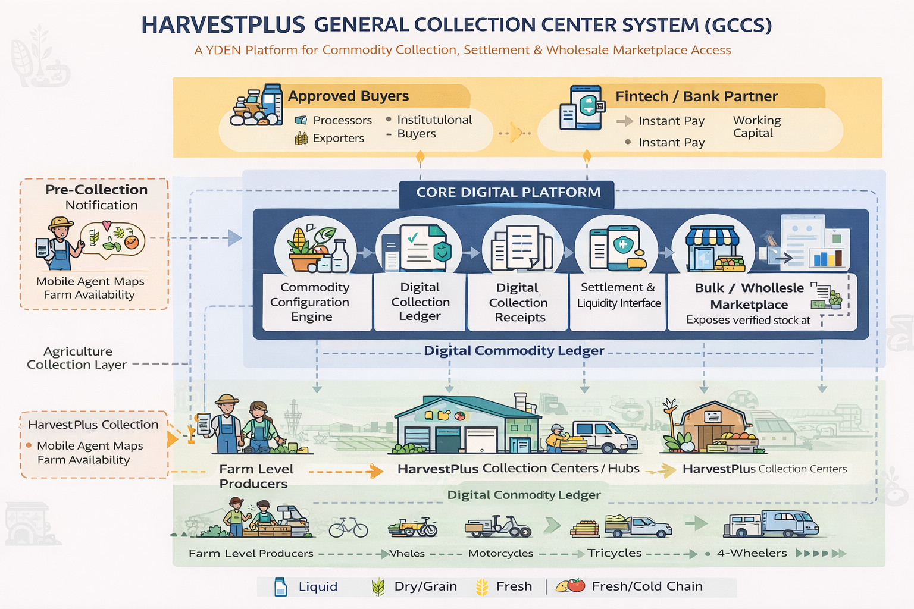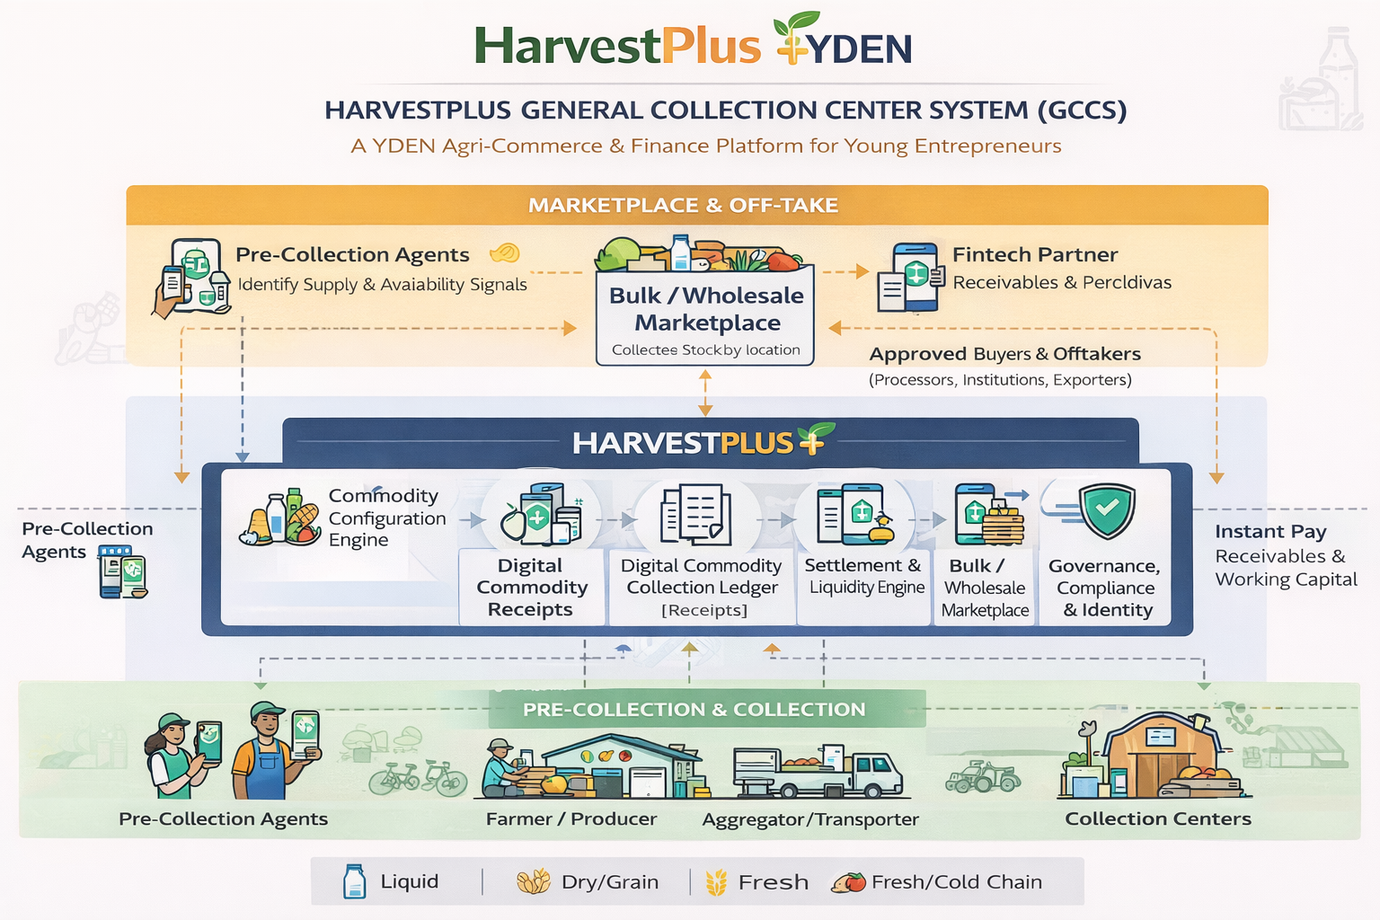

SYSTEM ARCHITECTURE REQUIREMENTS DOCUMENT (REVISED)

HarvestPlus General Collection Center System (GCCS)

A YDEN Technology for Market Access, Settlement & Trade Enablement
Version: 1.1
Owning Network: Young Digital Entrepreneurs Network (YDEN)
Deployment Brand: HarvestPlus
System Class: Multi-Commodity Collection, Settlement & Marketplace Infrastructure

1. System Purpose & Strategic Intent
The HarvestPlus GCCS is a core technology of the Young Digital Entrepreneurs Network (YDEN), designed to remove structural barriers that prevent young food systems entrepreneurs from:
- Accessing markets
- Accessing modern trade infrastructure
- Accessing timely payments and liquidity
- Participating competitively in formal value chains
The system provides a shared, national-grade digital infrastructure that enables young entrepreneurs to participate as:
- Individual producers
- Producer groups & cooperatives
- Aggregators & transporters
- Early-stage processors
- Large-scale processors (offtakers)
without requiring them to individually invest in costly systems or negotiate asymmetric market power.

2. Target Users (Primary Beneficiaries)

2.1 Entrepreneur Profiles (YDEN Core)
Segment | Description
Farm-level producers | Individual or grouped youth producers
Producer groups | Informal groups, cooperatives, associations
Aggregators / transporters | Youth-led logistics using bicycles, motorcycles, tricycles, 4-wheelers
Early-stage processors | Small processors needing steady supply & market access
Large processors | Anchor offtakers & liquidity anchors
📌 All users join the platform through YDEN under the HarvestPlus brand.

3. System Scope

In Scope
- Multi-commodity collection & aggregation
- Digital commodity ledger
- Commodity receipts (financial-grade)
- Instant & deferred settlement
- Bulk / wholesale marketplace exposure
- Transport & aggregation workflows
- Processor & institutional offtake integration

Out of Scope (Initial Phase)
- Retail consumer marketplace
- Speculative trading
- Deposit-taking financial services

4. Design Principles (YDEN-Aligned)
- Entrepreneur-First Infrastructure
Reduce barriers, not add compliance burden.
- One Platform, Many Roles
Users may act as producers, aggregators, or processors.
- Asset-Light Participation
Youth can participate with bicycles, motorcycles, or mobile phones.
- Market Access Before Subsidy
Focus on connecting supply to demand, not grants.
- Digital Trust as a Public Good
Verified data enables finance, pricing, and inclusion.

5. High-Level Architecture (Updated)
The HarvestPlus GCCS consists of seven core layers:
- Physical Collection & Transport Layer
- Commodity Configuration Engine
- Digital Collection Ledger
- Commodity Receipt Layer
- Settlement & Liquidity Layer
- Bulk / Wholesale Marketplace Layer
- Governance, Identity & Compliance Layer

6. Functional Requirements (Expanded)

6.1 Physical Collection & Transport Layer
FR-1:
The system SHALL support collection at:
- Farm gate
- Village hubs
- Collection centers
- Cold rooms
- Processor intake points
FR-2:
The system SHALL support multiple transport modes:
- Bicycles
- Motorcycles
- Tricycles
- 4-wheel vehicles
FR-3:
Aggregators SHALL be able to register routes, capacity, and delivery history.

6.2 Commodity Configuration Engine
(Unchanged core, but now YDEN-wide)
FR-4:
The system SHALL support configuration for:
- Liquids (milk)
- Dry grains (maize, beans)
- Fresh produce (horticulture)
- Other food commodities

6.3 Digital Collection Ledger
FR-5:
Each delivery SHALL generate a HarvestPlus Collection Record tied to:
- YDEN user ID
- Role at time of transaction
- Location & transport method
FR-6:
Ledger SHALL create reputation and performance histories for youth entrepreneurs.

6.4 Commodity Receipt Layer
FR-7:
Accepted deliveries SHALL generate HarvestPlus Commodity Receipts, which:
- Represent verified stock
- Are time-bound (perishable or non-perishable)
- Can be settled or financed

6.5 Settlement & Liquidity Layer
FR-8:
The system SHALL support:
- Instant Pay (fintech)
- Scheduled Pay (processor cycle)
- Hybrid advance models
FR-9:
Payments MAY be routed to:
- Individual producers
- Aggregators
- Group accounts

6.6 Bulk / Wholesale Marketplace Layer (NEW)
This layer exposes verified collected stock to approved offtakers.

Marketplace Principles
- B2B only
- Login-restricted
- Stock-backed listings
- No speculative listings

FR-10: Stock Visibility
The system SHALL display:
- Commodity type
- Quantity available
- Quality grade
- Location
- Expiry window
- Delivery terms

FR-11: Approved Offtakers
Only authenticated and approved buyers (processors, institutions, exporters) SHALL:
- View stock
- Place offtake requests
- Enter supply agreements

FR-12: Marketplace → Settlement Integration
When stock is matched:
- The marketplace SHALL trigger:
  - Delivery workflow
  - Receipt assignment
  - Settlement rules

6.7 Governance, Identity & Compliance Layer
FR-13:
All users SHALL have a YDEN identity with role-based permissions.
FR-14:
HarvestPlus SHALL act as:
- Platform operator
- Standards enforcer
- Neutral market facilitator

7. Non-Functional Requirements

Security
- RBAC by role & commodity
- Financial-grade audit logs

Performance
- High-frequency transactions (milk)
- Bulk listings (grains)

Accessibility
- Mobile-first
- Offline-first for rural users

8. Data Ownership & Use
- Producers own delivery data
- Aggregated insights MAY be used for:
  - Market intelligence
  - Policy learning
- No sale of personal data

9. Regulatory Posture
The system:
- Does NOT hold deposits
- Does NOT lend
- Operates as:
  - Trade documentation
  - Payment orchestration
  - Market access infrastructure

10. Pilot Configuration (YDEN × HarvestPlus)
Parameter | Value
Lead Network | YDEN
Deployment Brand | HarvestPlus
Commodities | Milk, Grains, Horticulture
User Focus | Youth entrepreneurs
Marketplace | Wholesale B2B
Fintech | ≥1 partner

11. Strategic Impact (YDEN Lens)
HarvestPlus GCCS enables YDEN to:
- Offer technology as shared infrastructure
- Create youth-led market access
- Build data-driven trust
- Unlock private capital participation

12. Summary Statement
HarvestPlus is the technology arm of YDEN that transforms young entrepreneurs from price-takers into market participants by giving them access to national-grade collection, settlement, and marketplace infrastructure.

USER JOURNEY MAPS

HarvestPlus (YDEN) – Multi-Commodity Trade Infrastructure

JOURNEY 0: PRE-COLLECTION AGENT (NEW, CRITICAL ROLE)
Purpose: Surface supply before trucks move.

Actor
- Pre-Collection Agent (PCA)
  - Youth-based field agent
  - OR digital self-reporting by farmer
  - OR cooperative-appointed scout

Journey Steps
0.1 Supply Discovery
- PCA visits farms OR receives farmer input via USSD/app
- Captures:
  - Commodity type
  - Estimated quantity
  - Readiness date/time
  - Quality indicators (basic)
  - Location (GPS or village)
  - Storage condition (cold/ambient)
0.2 Availability Signal Creation
- System generates a Pre-Collection Availability Signal
- Signal is:
  - Time-bound
  - Non-binding
  - Visible to aggregators
0.3 Aggregator Matching
- Aggregators see:
  - Nearby available commodities
  - Volumes clustered by route
  - Transport requirements
📌 This prevents empty trips and speculative collection.

Value Created
- Aggregators plan routes efficiently
- Farmers get visibility without commitment
- System builds predictive supply intelligence

JOURNEY 1: FARMER / PRODUCER
Purpose: Turn produce into a verified, paid delivery.

1.1 Registration & Identity
- Farmer joins HarvestPlus via YDEN
- Registers as:
  - Individual producer
  - Group / cooperative member

1.2 Pre-Collection (Optional but encouraged)
- Farmer:
  - Self-reports availability
OR
  - Confirms PCA-captured signal

1.3 Collection Day
- Aggregator arrives
- Commodity is:
  - Measured
  - Visually checked
- Temporary pickup record created

1.4 Delivery Confirmation
- At collection center:
  - Final quality verification
  - Quantity confirmed
- Digital Collection Record created

1.5 Payment
- If instant pay enabled:
  - Farmer paid same day
- Else:
  - Farmer sees settlement date

Farmer Gains
- Predictable market access
- Transparent pricing
- Faster payments
- Digital production history (credit-ready)

JOURNEY 2: AGGREGATOR / TRANSPORTER
Purpose: Move commodities efficiently and get paid without pre-financing.

2.1 Route Planning (Powered by Pre-Collection)
- Aggregator dashboard shows:
  - Nearby availability signals
  - Volume clusters
  - Commodity type
  - Urgency (expiry risk)

2.2 Route Acceptance
- Aggregator selects:
  - Route
  - Expected pickup volumes
- System reserves availability window

2.3 Collection Execution
- Aggregator:
  - Collects from farms
  - Confirms pickup in app
  - Tracks transport mode (bike, moto, truck)

2.4 Delivery to Collection Center
- Aggregator delivers commodity
- Collection center verifies:
  - Quantity
  - Quality
- Aggregator delivery record closed

2.5 Payment
- Aggregator:
  - Receives instant pay (if enabled)
  - Or sees scheduled settlement
📌 No more pre-financing farmers.

Aggregator Gains
- Route efficiency
- Reduced working capital pressure
- Digital reputation & performance score

JOURNEY 3: COLLECTION CENTER / HUB
Purpose: Convert physical deliveries into trusted digital assets.

3.1 Intake & Verification
- Staff:
  - Validate quantity
  - Apply quality tests (commodity-specific)
  - Capture storage conditions (temp, moisture)

3.2 Digital Ledger Entry
- System creates Collection Record
- Tied to:
  - Farmer
  - Aggregator
  - Location
  - Commodity profile

3.3 Commodity Receipt Generation
- Upon acceptance:
  - Commodity Receipt is created
  - Tagged as:
    - Perishable / non-perishable
    - Expiry window
    - Eligible for settlement/financing

3.4 Stock Exposure to Marketplace
- Receipt becomes visible inventory in:
  - Bulk / wholesale marketplace
  - Only to approved offtakers

Collection Center Gains
- Reduced cash stress
- Better utilization
- Quality-based differentiation

JOURNEY 4: BULK / WHOLESALE MARKETPLACE (B2B)
Purpose: Match verified stock with real demand.

4.1 Stock Listing (Automatic)
- Marketplace displays:
  - Commodity
  - Quantity
  - Grade
  - Location
  - Expiry
  - Delivery terms

4.2 Buyer Discovery
- Approved processors / institutions log in
- Filter by:
  - Volume
  - Location
  - Quality
  - Time window

4.3 Of﻿ftake Request
- Buyer places:
  - Full or partial offtake request
- System:
  - Locks relevant receipts
  - Triggers delivery workflow

Marketplace Gains
- No fake listings
- No speculation
- Real stock only

JOURNEY 5: PROCESSOR / OFFTAKER
Purpose: Secure supply without managing upstream chaos.

5.1 Login & Approval
- Processor approved by HarvestPlus/YDEN
- Sets:
  - Accepted commodities
  - Quality thresholds
  - Settlement terms (T+N)

5.2 Of﻿ftake Confirmation
- Processor:
  - Confirms delivery
  - Accepts quality
- Receipt becomes payable obligation

5.3 Settlement
- Processor pays:
  - Fintech (if instant pay used)
  - Or directly via platform

Processor Gains
- Reliable supply
- Lower transaction costs
- Cleaner reconciliation

HOW PRE-COLLECTION AGENTS CHANGE EVERYTHING
Without PCA | With PCA
Reactive collection | Predictive routing
Empty trips | Optimized logistics
Price uncertainty | Pre-signaled volumes
Fragmented supply | Clustered aggregation
📌 This is the intelligence layer that makes the system scalable.

SUMMARY FLOW (ONE-LINE)
Pre-collection signals → Verified collection → Digital receipts → Marketplace exposure → Settlement

